Integrated Science Year 11 ATAR

Properties of Sound

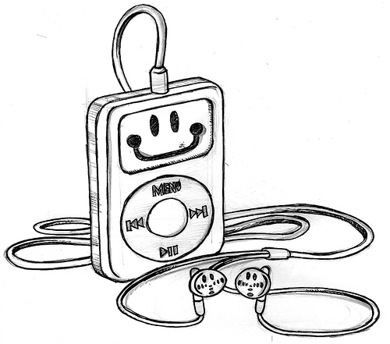

Section A: Multiple Choice 15 marks

Section B: Short Answers 30 marks

Section A: Multiple Choice (15 marks)

- The number of vibrations per second is called the:

  - loudness
  - frequency
  - amplitude
  - quality

- The loudness of a sound is determined by which characteristic of the sound wave:

  - amplitude
  - loudness
  - frequency
  - quality

- Soundwaves cause compressions and rarefactions as they travel through air. The frequency of the sound depends on,

  - how large the compressions are.
  - how large the rarefactions are.
  - the number of rarefactions.
  - the number of compressions produced in a second.

- Which of the following best describes how sound is produced?

  - Particles of air move from one place to another.
  - An object changes its position.
  - An object moves rapidly from one place to another.
  - Particles of matter move backward and forward transferring energy.

- A student set up an experiment. He found that by gently tapping each nail a different type of sound was produced.

Nails

Wood

The experiment showed him that:

  - sound travels through any vibrating object.
  - the type of sound depends on the length of a vibrating material.
  - sound does not travel through steel.
  - the length of the nails had no effect on frequency.

- Multiple reflection of sound is called

  - acoustic tiles
  - an echo
  - a reverberation
  - amplitude

- When a sound wave travels through a medium

  - particles are transferred from one place to another.
  - energy is transferred from one place to another intermittently.
  - energy is transferred at a constant speed.
  - particles do not move.

- The minimum distance away from a wall a person should stand and make a loud noise, so that an echo can be heard, is approximately

  - 10 m
  - 17 m
  - 34 m
  - 43 m

- Which of the following uses the reflection of sound?

  - A stethoscope
  - Fish finder
  - Flash of lightning
  - Telephone

- Bats detect objects in front of them by receiving the reflected

  - infrasonic sound.
  - radio waves.
  - electromagnetic waves
  - ultrasonic waves.

- The relation between wave velocity (v), frequency ( f ) and wavelength (ƛ)

  - v = f
ƛ
  - v = f ƛ
  - v = ƛ
f
  - v = 1
f ƛ

- Which of the following is the best absorber of sound?

  - Cement
  - Metals
  - Thick carpet
  - Thin curtains

- Sound wave cannot travel through a

  - vacuum
  - solid
  - liquid
  - gas

- The following table gives some examples of noise levels.

Source | Sound Level (decibels)
Riveting | 130
Jet aircraft at 100m | 110
Sports car | 90
Busy street | 70
Quiet street | 50
Loud whisper | 30

A motorcycle can be expected to give a noise level in range:

  - Greater than 130 decibels.
  - Between 30 decibels and 70 decibels.
  - Between 70 decibels and 110 decibels.
  - Less than 50 decibels.
A

B
C

D

The amplitude of the wave is indicated by the letter:

  - A
  - B
  - C
  - D

End of Section A

Integrated Science 2A

Adolescents & Music

Name: ___________________________

1. | a | b | c | d
2. | a | b | c | d
3. | a | b | c | d
4. | a | b | c | d
5. | a | b | c | d
6. | a | b | c | d
7. | a | b | c | d
8. | a | b | c | d
9. | a | b | c | d
10. | a | b | c | d
11. | a | b | c | d
12. | a | b | c | d
13. | a | b | c | d
14. | a | b | c | d
15. | a | b | c | d

Section A: Multiple Choice _______ / 15 marks

Section B: Short Answers _______ / 30 marks

Total _______ / 50

_______ %

Section B: (20 marks)

- Explain why sound can’t travel through a vacuum? (2 marks)

In a vacuum there are no particles (1) to transfer energy/vibrations from particle to particle(1)

- Explain why sound travels faster through solids than through liquids. (2 marks)

Particles are close together (1) so energy/vibrations can move quicker (1)

- Draw a diagram of a longitudinal wave which shows four compressions and three rarefactions. On your diagram label the compressions, rarefactions and wavelength. (4 marks)

The following calculation questions will need to be completed using the following wave equation
v = f ƛ
- Calculate the speed of a wave with a frequency of 1000 Hz and a wavelength of 5 m. (2 marks)

f = 1000Hz v = 1000 x 5
ƛ = 5 m = 5000 m s⁻¹

- Calculate the frequency of a wave travelling at 500 m s⁻¹ with a wavelength of 25 m. (2 marks)

v = 500 f = 500
ƛ = 25 m 25
= 20 Hz

- Two half-empty bottles are floating in the ocean. They are 16 m apart. If they are both on the top of a crest at the same time and at that time they are 3 wave crests between them, what is the wavelength of the waves? (2 marks)

16 = 4 m
4

- A fighter plane is travelling at Mach 1.5, what is the speed in metres per second the plane is flying at if the speed of sound is 340 m s⁻¹? (2 marks)

340 x 1.5 = 510 m s⁻¹

- What causes a sonic boom? (3 marks)

A shockwave that is created when a plane travels faster than the speed of compress . Sound waves compress to form the shockwave

- A group of friends have formed a band and need a place to practise. The garage at one of the friend's house can be converted to meet their needs. However, to avoid complaints from neighbours, the garage needs to be made soundproof. Design an investigation to test different materials that could be used to soundproof the garage

(i) Identify the dependent and independent variable. (1 mark)

Dependent: noise level
Independent : sound proofing material

(ii) Formulate a hypothesis for this investigation. (1 mark)

Thick soft material will be better at absorbing sound

(iii) Identify and describe three variables that need to be taken into consideration during this
investigation. (1 mark)

same source for sound, same thickness for material, same frequency of sound, same loudness for sound and any other reasonable

(iv) Describe the procedure you would use to carry out this investigation. (4 marks)

- Any reasonable showing controlling variables and measurement technique

